01. Quarterback Rating

Program Name: Quarterback.java Input File: quarterback.dat
Your friend needs to calculate the passer rating for every NFL quarterback that plays that week. However he is way too lazy to do that and comes to you for assistance.
The quarterback rating is calculated by using the formulas below:

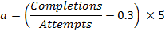

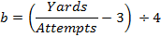

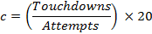

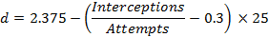

Input
The first line of input contains a single integer n which indicates the number of test cases that follow. Each n lines that follow will contain 5 integers, c (Completions), a (Attempts), i (Interceptions), y (Yards), t (Touchdowns).
Output
Print out the passer rating rounding to two decimal places.
Constraints
0 < n < 10
0 < c ≤ 2500
c ≤ a ≤ 2500
0 ≤ i ≤ 2500
0 ≤ y ≤ 5000
0 ≤ t ≤ 2500
Example Input File
4
289 479 10 3238 21
163 272 4 2144 15
310 517 17 4051 21
20 28 0 218 1
Example Output to Screen
86.44
97.12
84.54
105.95

